Rainfall Prediction System Using Deep-Neural Network
Debraj Dhar, Sougato Bagchi, Chayan Kumar Kayal, Soham Mukherjee,
¹ Princeton University, Princeton NJ 08544, USA
² Springer Heidelberg, Tiergartenstr. 17, 69121 Heidelberg, Germany
lncs@springer.com
Abstract. Forecasting the weather has always been a challenge using conventional methods of climatology, analogue and numerical weather prediction. To improvise the prediction of weather much further, the proposed method can be used. In this work, authors proposed a method which uses the advantages of Deep Neural Network to achieve high degree of performance and accuracy compared to the old conventional ways of forecasting the weather. It does so by feeding the perceptrons of the DNN some specific features like Temperature, Relative Humidity, Vapor and Pressure. The output generated is a highly accurate amount of the rainfall based on the given input data.
Keywords: Forecast, Prediction, DNN, perceptrons.
- Introduction
A meteorologist’s biggest job is to predict how the weather will change depending upon the climate changing parameters and it has always been a challenging job to predict this on a higher scale of accuracy. Using DNN (Deep Neural Network), the task of predicting the weather can be achieved with much greater accuracy.
A few years back, using DNN would not have been possible due to lack of processing power and other factors. But now, the rapid growth in technological development have made it possible to use DNN Model to forecast weather at any given point of time.

An Artificial Neural Network (ANN) mainly consists of an Input Layer, an Output layer and a Hidden layer. A hidden layer contains many neurons also known as perceptron. Features or attributes acts as the input for the input layers and output layer generates the result while hidden layer performs various operations and finds the co-relation among the attributes to produce the output. But, when there exists more than two layers in a Neural network, it is then considered to be a “Deep Neural Network” (DNN). In the proposed work, authors have compared this DNN architecture with other conventional approaches like Multiple Linear Regression model (MLR) and ANN to establish the effectiveness of the DNN model.

Multiple linear regression is the most common form of linear regression analysis. As a predictive analysis, the multiple linear regression is used to explain the relationship between one continuous dependent variable and two or more independent variables. In traditional ways of predicting the rainfall, MLR was often used.
- Related Works
- Dataset Description
The dataset of our work has a total of 2485 rows and 14 columns. It contains information regarding the rainfall over a period of 7 years from 1989 to 1995.
There is a total of 14 attributes in the dataset. Out of those 14 attributes, we have used 8 attributes like temperature, vapor, relative humidity and pressure, which are some significant features in forecasting the rainfall.
The following plots shows the relation between the attributes and the rainfall based on the actual dataset –

Figure 1. Plot of Pressure vs Rainfall
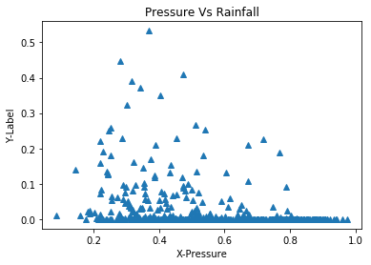

Figure 2. Plot of Vapour vs Rainfall
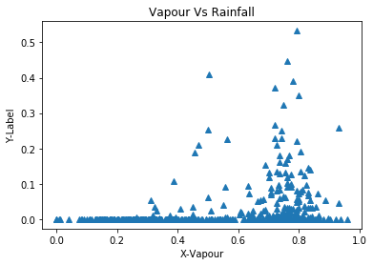

Figure 3. Plot of Relative Humidity vs Rainfall
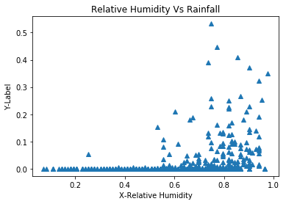

Figure 4. Plot of Temperature vs Rainfall
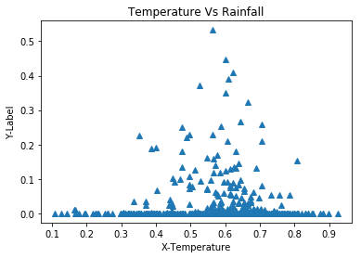

- Proposed Method
In this work, we have made a DNN Regressor Model, consisting of 6 hidden layers and each layer having 100 neurons. The number of hidden layers and neurons taken are completely arbitrary. At first, all the features i.e. the parameters responsible for weather prediction are given to the Input layer to train the regressor model. The following steps are taken as a basic flow of experiments –
- Pre-processing: The following pre-processing is done in the dataset before the regression.

- Feature Extraction - This step involves extraction of significant features which are most important in regression using the statistical correlation method.

- Data Cleaning - The dataset might contain missing or inconsistent values. To deal with such issues statistical methods are used in this step of pre-processing.

- Data Normalization – The normalization of the dataset is carried out to reduce the distance between attribute values. It is generally achieved by keeping the value range in between -1 and +1.
2. After the pre-processing of the database, the database was then split into training and testing set in a ratio of 70:30. Both the training and testing set data had been shuffled to get the optimal result at the end of the experiment.
3. In the training phase, the training dataset was supplied to the DNN regressor model authors had previously built to train the model. The optimizer used to reduce the generated error was “Adagrad” optimizer and the activation function used in the work was “RELU” with a learning rate of 0.03.

4. In the testing phase, the test dataset was supplied to the DNN model to evaluate the performance of the whole process.
To measure the performance, some statistical approaches were used to get the error loss and accuracy of the model.

Figure 5. Flow-Chart of the methodology of the DNN model

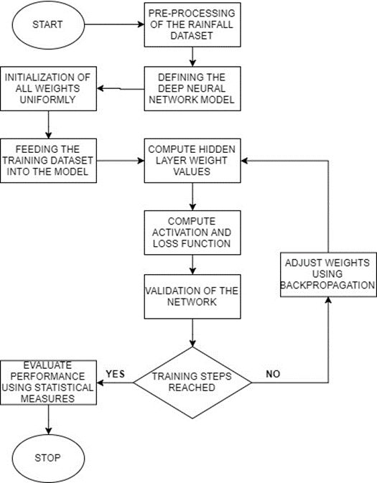

- Results and Discussions
After training a total 1738 rows in a shuffled order for 5000 steps, the DNN model produced a final loss of: 0.00589925.
During the evaluation of the test dataset, the model evaluated as following:
• Average loss: 0.0041428246,
• Global steps: 5000,
• Loss: 0.03287816

Figure 6. Plot of the original test dataset

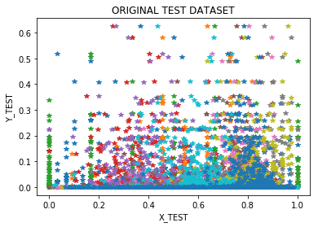

Figure 7. Plot of the Predicted test dataset

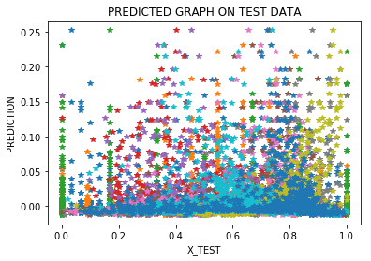

Figure 8. Plot of the original vs test dataset

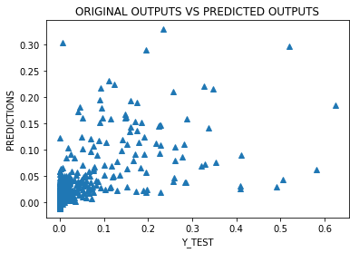

Table 1. Comparison between estimated and observed rainfall

 | Estimated Rainfall | Observed Rainfall
Min | 0.002 | 0.0
Max | 0.52 | 0.62
Mean | 0.03 | 0.03
Standard Deviation | 0.05 | 0.07

The min, max, mean and standard deviation of estimated and observed rainfall are shown in Table 1. These statistics are more or less similar.

After comparing the results of DNN model to an ANN Model and a MLR model in terms of MSE, RMSE and R² Parameters, authors got the following result:

Table 2. Comparison between different models

 | MSE | RMSE | R-Squared
DNN | 0.0037 | 0.0609 | 37.51
ANN | 0.0052 | 0.0721 | 39.73
MLR | 0.0098 | 0.0989 | 35.24

MSE (mean squared error) is the square loss of the difference between actual value and the predicted value. It determines how far the data points are from the actual value itself. From the observations, the loss on the DNN model is significantly lower than both the ANN and the traditional MLR model.

- Conclusion
From all the experiments conducted over this dataset with the DNN Regressor model, the results have been proven to be of satisfactory amount of improvement over the existing forecasting methods of numerical and statistical predicting methods. But even though, the loss is much less than conventional models, the implementation of this model for large datasets will require a lot of processing power to do so. The present work has analyzed the performances of the model in terms of several performance measuring parameters like mse, rmse, r-squared to provide a vivid picture of the exact performance of the DNN model. In future, using DNN model, other weather parameters like radiation can also be calculated.

Reference
- Gong, P. and Howarth, P.J., 1992, Frequency-based contextual classification and gray-level vector reduction for land-use identification. Photogrammetric Engineering and Remote Sensing, 58, pp. 423–437.
https://ci.nii.ac.jp/naid/80006391998/

- Mathie, M., Coster, A., Lovell, N., and Celler, B.: ‘Accelerometry: Providing an integrated, practical method for long-term, ambulatory monitoring of human movement’, Physiol. Meas., 2004, 25, pp. 1–20

- Foerster, F., and Fahrenberg, J.:’Motion pattern and posture: Correctly assessed by calibrated accelerometers’, Behav. Res. Methods Instrum. Comput, , 2000, 32(3), pp. 450–457

